Is this report confidential? | No
Report of | Meeting | Date
Director of Governance and Monitoring Officer  (Introduced by the Leader of the Council and Cabinet Member (Strategy and Reform) | Council | Wednesday, 18 May 2022
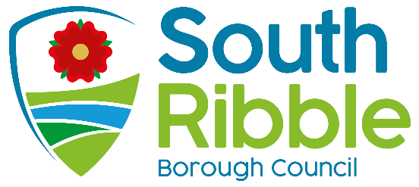
Is this decision key? | Not applicable

Report of the Independent Remuneration Panel

Purpose of the Report
- The report informs Council of the findings and recommendations of the Independent Remuneration Panel, which has completed a review of members’ allowances under the Local Authorities (Members’ Allowances) (England) Regulations 2003.

Recommendations to Council
- That Council considers the Independent Remuneration Panel’s report and decides what action it wishes to take on the Panel’s recommendations for a new Scheme of Members’ Allowances.

Reasons for recommendations
- Council must have regard to recommendations of the Independent Remuneration Panel if it wishes to make a new Scheme for members’ remuneration or amend the existing Scheme.

Other options considered and rejected
- It is for Council to consider if they wish to accept or reject the Panel’s recommendations, in whole or in part.

Corporate priorities
- The report relates to the following corporate priorities:

An exemplary council | Thriving communities
A fair local economy that works for everyone | Good homes, green spaces, healthy places

Background to the report
- The Council is required under paragraph 20 of the Local Authorities (Members’ Allowances) (England) Regulations 2003 to appoint and maintain an Independent Remuneration Panel, to review and make recommendations to the Council on the Members’ Allowances Scheme.

- The Council can choose whether or not to implement those recommendations.

- The members of the Independent Remuneration Panel were appointed by the Council in July 2021.

- The current Members’ Allowance Scheme was approved at the Council in September 2015. The regulations state that every 4 years a review of the scheme should be undertaken. This review was delayed by the COVID pandemic; however it has now been completed.

Requirements and current Scheme
- The Regulations state that each Authority must make a Scheme which includes a Basic allowance and Special Responsibility Allowances (SRA) for special responsibilities. The current Scheme includes a schedule of allowances which the Council pays to its Elected Members.

- A scheme may also provide for:
- Dependants' carers' allowance
- Travelling and subsistence allowance
- Co-optees' allowance

Climate change and air quality
- This report does not impact the climate change and sustainability targets of the Councils Green Agenda and all environmental considerations are in place.

Equality and diversity
- There are no equality and diversity implications arising from this report.

Risk

There are no risks arising from this report.

Comments of the Statutory Finance Officer
- The additional costs of the recommended changes are £7,262 which can be managed within existing budgets. The increase reflects the following recommendations of the Panel:
- Lead Members - 3 X £1500;
- 1 X Deputy Leader of the Opposition £1500;
- 1X Leader of a Small Group £1000;
- Increase in SRA for 1 X Licensing and Public Safety Committee – from £3,491.85 to £3,753.72

Comments of the Monitoring Officer
- There are no issues of concern to raise from a Monitoring Officer perspective. Clearly proper procedures have been followed in this instance. It is a matter of discretion for Council to decide on what action it wishes to take in respect of the Panel’s recommendations.

Background documents
Local Authorities (Members’ Allowances) (England) Regulations 2003.

Appendices
Report of the Independent Remuneration Panel
Report Author: | Email: | Telephone: | Date:
Clare Gornall (Democratic and Member Services Officer) | clare.gornall@southribble.gov.uk |  | 3 May 2022

